- \Operation\Basic settings\Speed
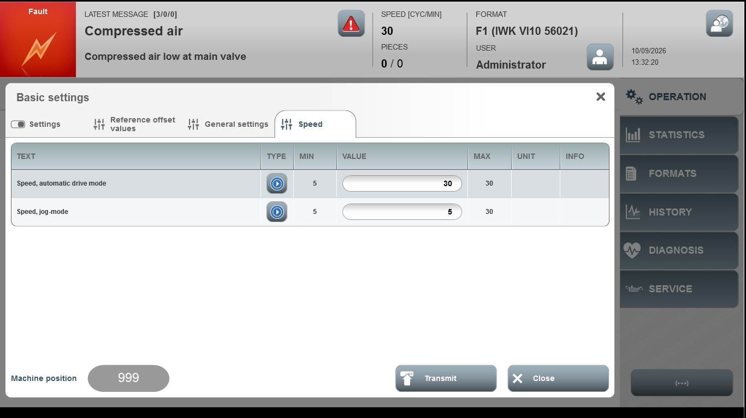
Acceptance criterion | Limits | Pass / Fail: Dev-No. | Date | Initials
Screen matches screenshot | N / A
Speed, automatic drive mode | 5 … 30
Speed jog-mode | 5 … 20

